The following is a summary of the impacts of the pre-college education programs of the Center for Subsurface Sensing and Imaging (CenSSIS), based at Northeastern University (NU) in Boston. It was provided by Claire Duggan, who has served as the CenSSIS K-14 Outreach Director from its initiation in 2000 and since its graduation from the ERC Program in 2010. In partnership with the CenSSIS Director, Dr. Michael Silevitch, Duggan achieved greater long-term overall success with their precollege education programs than perhaps any other ERC. See http://www.censsis.neu.edu/education/k12_programs/)
------------------------------------------------------
Overview
Today, the establishment and the continued activities of the Center for STEM Education at Northeastern (www.stem.neu.edu) are primarily the result of the early education efforts of the CenSSIS ERC. The CenSSIS RET, REU, and Young Scholar (with over 500 alumni) programs continue at different levels. The relationships established through those early ERC efforts with teachers, school districts, and community colleges have led to many other NSF-funded grant initiatives, such as NSF STEP, S-STEM, ATE (Advanced Technological Education) and ITEST (Innovative Technology Experiences for Students and Teachers). The figure depicts the 30-year history of NSF-funded K-14 education programs at NEU, both before and after the period of CenSSIS ERC Program funding.
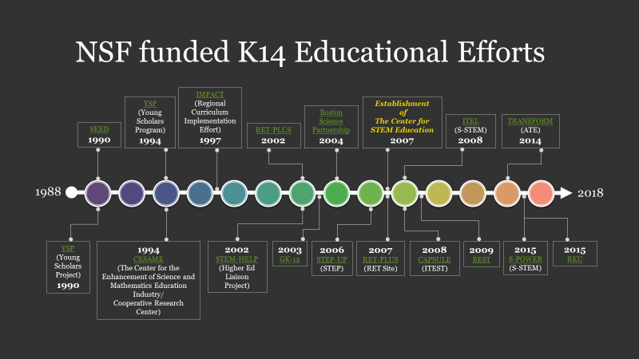
Our Research Experiences for Teachers (RET) alumni community continues to inform our work, especially in the development and implementation of Broader Impacts requirements of grants across the College of Engineering. Their contributions led to continued expansion and support for engineering integration in K-12, in addition to the establishment of a STEM Field Trip series we offer on our campus (supported by 75+ undergraduate students) to introduce primarily elementary and early middle school students to engineering. We reach approximately 2000 urban students through these outreach efforts.
Details About Programs
Research Experiences for Teachers
Following the ERC’s graduation from ERC Program support, RET opportunities continued with NSF supplements primarily, to faculty awards from across the College of Engineering. NU’s Center for STEM has applied for several sites, but has not received another site award. The last RET award ran through 2011 and involved multiple school districts.
CenSSIS and the Center for STEM have maintained an active network with their former RET teachers (several of whom have assumed district leadership positions). Many participated in the ITEST grant, CAPSULE. Claire Duggan was a Co-PI of that grant effort. https://stem.neu.edu/programs/past/capsule/ CAPSULE, a capstone project-based learning model, brings the STEM/IT workforce experience to high school students and teachers through industry-driven projects and multimedia production. Materials developed at the Museum of Science and real-world problems solicited from local industry are formulated as projects to be used in a hands-on capstone elective course or in after-school activities, so that students can relate STEM concepts covered in the classroom to real-world applications and learn the engineering design process (EDP).
As part of the course, students visit companies to learn first-hand about the day-to-day activities of the STEM/IT workforce. They also produce their own media content for their projects. Each year, 30 high school teachers engage in a two-week summer professional development workshop, with follow-up during the year for a total of 120 hours. Activities are developed for school administrators, guidance counselors, and parents to make them aware of the value and importance of STEM/IT careers and opportunities. The project outcomes are: (1) pedagogically proven EDP-based curricula that can be replicated at the local, regional, and national levels; (2) teachers who connect STEM content to real-world applications; (3) students who discover the real value of STEM subjects; and (4) a means to address Massachusetts’ shortage of teachers with sufficient background to teach engineering and technology in schools. The evaluation plan focuses on the quality of professional development, student learning, and perceptions of STEM careers. Partners include high schools, local industry, Northeastern University engineering research centers and the Center for STEM Education, and the Boston Museum of Science (MoS).
As part of that effort, the Center for STEM collaborated with the MoS to produce a film focusing on the state of K-12 engineering education in Massachusetts. https://www.youtube.com/watch?v=Wqsty5Y0iO8&feature=youtu.be The 2011 film, “Hands-On, Minds-On: Bringing Engineering Design to High School Classrooms,” by Emmy Award-winning producer Lawrence Klein, tackles the huge issue of motivating students to achieve mastery in the science, engineering, and technology areas most likely to prepare them for productive, high-paying jobs. In the film, five Massachusetts high school teachers inspire their students by bringing engineering design challenges into STEM curricula at five very different public schools—an urban arts academy, a regional voc-tech institute, a special-needs school, a factory-town high school, and a typical suburban “no-shops” high school. MoS executive producer Carol Lynn Alpert developed the film in collaboration with the Museum’s Educator Resource Center, the National Center for Technological Literacy, Boston Public Schools and Northeastern University, with support from the National Science Foundation (award #DRL-0833636).
In addition, dedicated websites such as https://collapseresistance.weebly.com/ were developed and continue to be shared with our collaborative teacher community through The Center for STEM Education.
Research Experiences for Undergraduates
CenSSIS’ s REU Program survived after the ERC graduated from ERC-program support. In addition, Center collaborative faculty continued pursuing REU Sites awards.
The NSF REU-D3 program provides a multi-disciplinary research experience for rising sophomore undergraduates, offering 10-week summer-based experiences in computer science/engineering laboratories, allowing for work on both fundamental and applied data-driven problems, focused on machine learning techniques, data analytics, and computational technologies. The REU site works to create a mentoring ecosystem at both Northeastern University and the partnering institutions, developing a model that is transferrable to other institutions. CenSSIS plans to leverage the Massachusetts Green High Performance Computing Center (MGHPCC) to provide a backdrop for this cross-disciplinary REU program that will engage undergraduates in opportunities that focus on data analytics and computing. The program will also build relationships with six urban community colleges/universities to build a pipeline of students, showing students potential pathways to graduate education/research. The program will leverage the NSF CISE Directorate’s REU Toolkit for pre- and post-program surveys, as well as for recruiting. The REU-D3 Site will work to effect changes in mentoring attitudes and practices at the host and partnering academic institutions.
Young Scholars Program
Through collaboration with The Center for STEM, CenSSIS has continued to offer a Young Scholars (YS) Program for high school students. (See https://stem.neu.edu/summer/ysp/ ) This effort was originally launched decades ago in collaboration with an NSF I/UCRC and continued and expanded throughout the life of the NSF-funded CenSSIS ERC. YS Program alumni can be seen at https://stem.neu.edu/summer/ysp/alumni/
About Claire Duggan
Claire Duggan was profiled in Ch. 7, Education and Outreach, section 7-E(a), Model ERC Educators, as one of the most notable ERC precollege education leaders. Partly in recognition of her success in these efforts not only in CenSSIS but throughout NU, in 2015 Duggan was inducted into the Massachusetts Hall of Fame for Science Educators.
CenSSIS Director Michael Silevitch notes that “CESAME and then the CenSSIS ERC opened up the door for Claire to engage in STEM educational initiatives. This became a passion for her that sustains her to this day.”
