-----------------------------------------------------------------------------------
CASE STUDY
CASA DFW Living Lab for Severe Weather Warning
Overview. One of the principal sustaining activities of the Collaborative Adaptive Sensing Systems (CASA) ERC is the CASA DFW Living Lab for Severe Weather warning in north Texas. Founded by Philips, Chandrasekar, and Bajaj, in conjunction with the public safety community in north Texas, the CASA living lab is an end-to-end severe weather warning and response infrastructure where research and live operations can be conducted during actual severe weather events. Our living lab encompasses the technology (7 CASA radars, other sensors, networks, computation), the high-resolution weather products (observations and forecasts for wind, hail, floods and tornados), decision-making tools (website display, mobile apps) and the key actors (emergency managers, NWS forecasters, media, industry and the public) in real-time, real-world situations. The warning system operates year-round disseminating weather products to over 1,500 public safety and industry stakeholders, who use the data for real-time decision making and also collaborate with CASA researchers to improve science and application. Figure 11-3 shows the layout of the network.
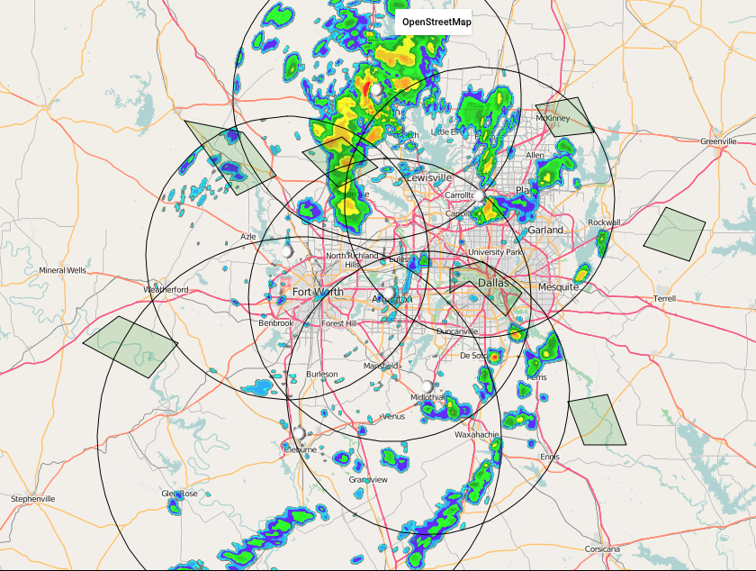
Figure 11-3: CASA Radar Network in Dallas Fort Worth showing 6 overlapping radars. CASA network covers approximately 32,000 sq. km. and a population of close over 7 million people. The radar range is 40 – 60km.
Multi-sector Partnerships. The living lab is operated through a public-private partnership led by the North Central Texas Council of Governments (NCTCOG) and CASA at UMass Amherst and at Colorado State University. We recently signed our second 5-year memorandum of agreement. A local Executive Committee composed of EMs, broadcast media, and NWS creates and implements local policies about the network. There is also a leadership committee composed on the NCTCOG, the co-chairs of the local Executive Committee, and UMass.
Warning Decision Making. CASA data is used during warning decision making by NWS forecasters, Emergency Managers, broadcast media, and industry to get geographically precise information on severe weather. Figure 11-4 shows how CASA data was used for tornado warning by the National Weather Service in Fort Worth.
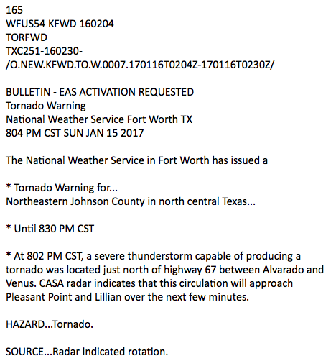
Urban Flash Floods. A suite of networked rainfall products that combine CASA and NEXRAD data has been offered to the community since late 2016. These products have been shown to localize flash flood risk (both in time and in space); and can be customized for different locations and applications. For example, networked rainfall is being used by the City of Fort Worth Emergency Management to deploy public safety personnel to areas of high flood risk and by the city of Plano and Dallas Fort Worth Airport for environmental monitoring.
Linking Technology, Policy, and Human Dimensions. CASA is changing the warning paradigm from a broadcast paradigm, where everyone gets the same warning message, to a context-aware paradigm, where individual people receive personalized warnings on a mobile app, CASA Alerts. This context-aware warning system directly links weather hazards (high rain, winds), the built and natural environment (roads, watersheds), and people’s precise location to deliver customized alerts. This innovative mobile app simultaneously provides weather information to the general public and serves as a research tool gathering data on the public’s severe weather perceptions and responses.
Figure 11-4: CASA data being used to issue a geographically precise Tornado Warning
Industry Involvement. The Living Lab operates as a “plug and play” platform where private and public entities can participate in specific parts of the network without having to incur the time and cost of creating their own end-to-end network. Private radar companies, EWR, EEC, Furono, and Ridgeline Instruments each donated a radar to the network to validate the technology and markets, which has resulted in sales of X-band radars. For example, EEC now supplies X-band radars to NBC nationally for its local weather broadcasts. Raytheon has tested next-generation flat panel fully electronic radars in the DFW testbed. On the application side, the Dallas Fort Worth Airport is using CASA data for ground-based airport operations. In addition, NBCDFW is displaying CASA data on air as part of a pilot program. (See Figure 11-5.). Lastly, CASA is part of a NASA grant to work with Bell Helicopter on providing targeted weather data for drone operations.
Funding. Radar operations are sustained through fees provided by the local government, which have totaled over $1 million, and through NOAA’s National Mesonet program. In addition, grants from NSF’s Hazards SEES program, Smart & Connected Communities, Partnerships for Innovation, Raytheon, Dallas Fort Worth Airport, and NASA/Bell Helicopter support continued advancement of research. Annual expenditures through these other sources are approximately $1 million.
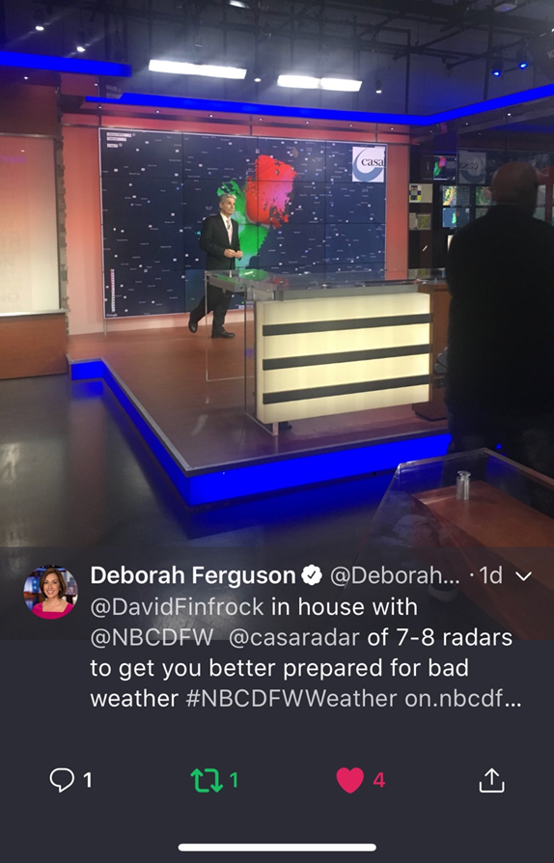
Figure 11-5: CASA data being used and discussed on-air by NBC-DFW (Source: Deborah Ferguson)

